Report
Forecasting of view trend for next 12 months:
Understanding:
Blue line: Overall predicted trend of the channel’s future Data.
Light Blue Shaded Area: possible range in which future Data might fall.(with 85-90% variation)
Black dots: Actual Data in the particular month

View Forecast
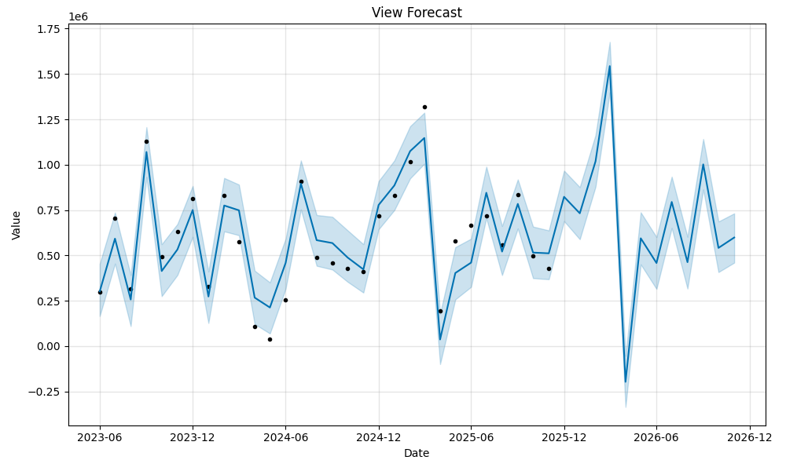
Comment forecast:
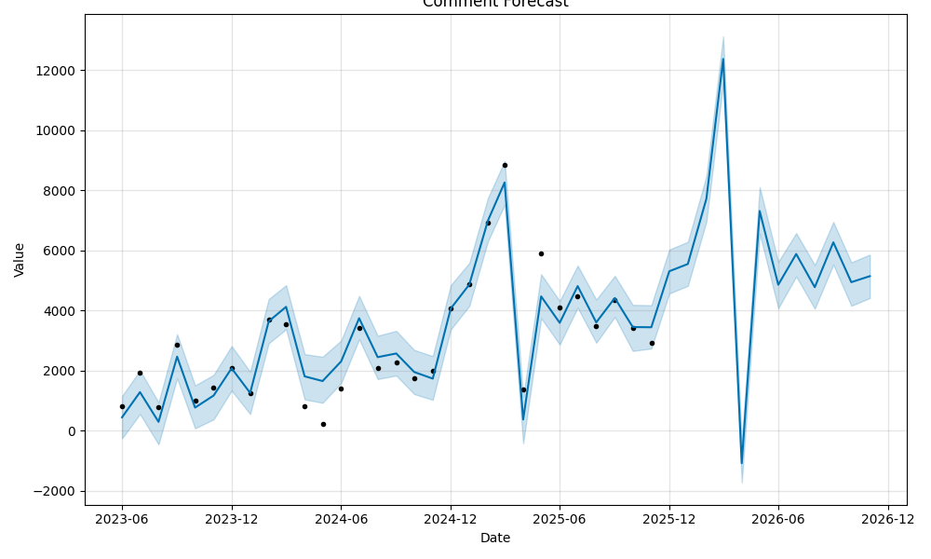
Like Forecast
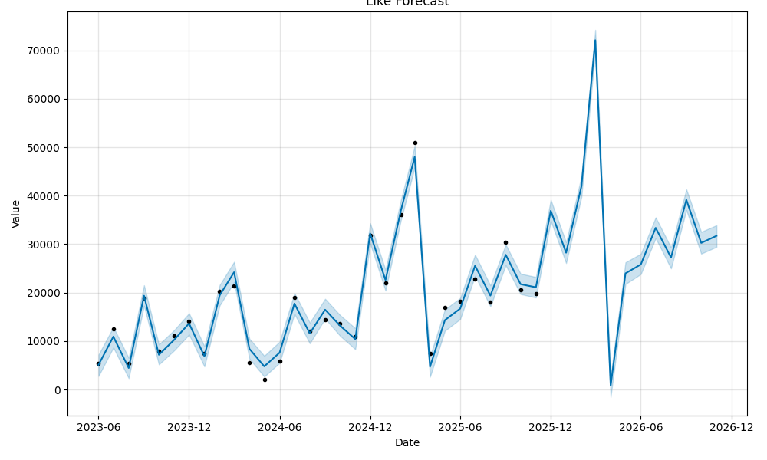

Summary:
The forecasting analysis for Views, Likes, and Comments indicates strong overall growth in the channel’s audience reach and engagement over time, despite short-term fluctuations. All three metrics show clear upward trajectories with recurring seasonal peaks, suggesting consistent content performance patterns and increasing viewer loyalty. A significant dip across all metrics is observed in early 2026, pointing to a one-time anomaly likely caused by reduced content activity or algorithmic shifts rather than long-term decline. Forecasts project steady recovery and stabilization afterward, with views returning to 500K–700K per month, likes rising to 30K+, and comments stabilizing around 5,000–6,000 monthly. Overall, the channel demonstrates healthy momentum, expanding engagement, and strong potential for sustained growth in the coming year.

